Four pillars of OOP(Python)

There are four pillors of OOP
- Inheritance
- Encapsulation
- Abstraction
- Polymorphism

- Inheritance

Python Inheritance
Inheretence allows one class to use/reuse the attributes and methods or features of another class
- Parent class:parent class also called base class the class which provides its methods and attributes to another class is called parent class
- Child class:it also called derived class ,the class which use/reuse the attributes and methods or we can say features of another class is called child or derived class
Explain why inheritance is useful in real programming?
- It allows code reuse
- It helps to avoid duplication of methods and attributes
- It makes easy to maintain and extend code

Create a Parent Class
- Defined using normal class syntax because any class can be parent class
- Contains attributes & methods

Create a Child Class
Also defined using normal class syntax but we pass the name of parent class in the parentheses to the child class so that it can inherit the attributes & methods of parent class
Or we can say :
It inherit parent class attributes and methods by writing parent class name in its parentheses

Add the __init__() Function
- __init__ is the built in method in python
- We use it to initialize the object attributes with values
- It called automatically when an object is created
- Self is a parameter we use in init method as a frst parameter to represent the current object
- Self allows acess to object attributes & methods
- __init__ sets attributes, it does not define methods inside it. It only call the methods
- Agar hum ny child class main parent class ko inherit kia h or child class main init method define kia h to yeh parent class k init function ko override kr dy ga so is liy humy parent class k init function ko sepratly call krny ke zrurat h inside child class
- Wrna child class main init function us ka apna seprate function ban jay ga or wo parent class k init function k attributes ko acess krny k bjay apny attributes sepratly use krna shuru kr dy ga,ab child class ka apna bhi init function define ho gia h or parent class k function ko bhi inherit kr lia h
- Inherit krny ka matlab h k wo attributes ko extend kr sky jo us ny parent class sy inherit kiy hain

Use the super() Function
- Hum usllay jab parent class k init function ko child classs main call krty hain to parent class ka name use krty hain Parentclass.__init__(self)
- is ka alternative yeh h k hum super function use kren instaed of using parentclass name
- like :Super().__init__(self)
- Its cleaner and avoid repeating class name
- We can direct assign value to the property inside a class using
self.graduationyear = 2019
- here wee need to use a variable instead of using “2019”
- instead we should use this value when we will be creating object using class inside the parameter of the class like:
self.graduationyear = year
creating object
x = Student("Mike", "Olsen", 2019)

Add Methods
- We can also define the custom methods or functions inside the classes alongside built in __init__() method
- If we add a method in the child class with the same name as in the parent class it will be overridden
- And the solution is same as we studied in __init__() method
Extra topics to learn in Inheritance :
Types of inheritance: single, multiple, multilevel, hierarchical
Single inheritance:
Single child class inherits from the single class
Example:
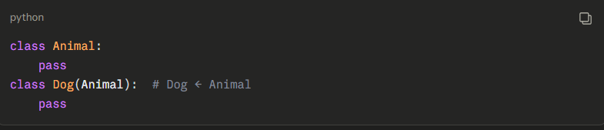
Multiple inheritance:
One child class inherits from multiple parent classes
Example:
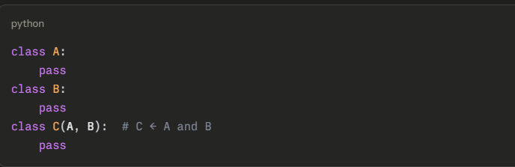
Multilevel inheritance:
A chain of inheritance(grandparent,parent,child)
Example:
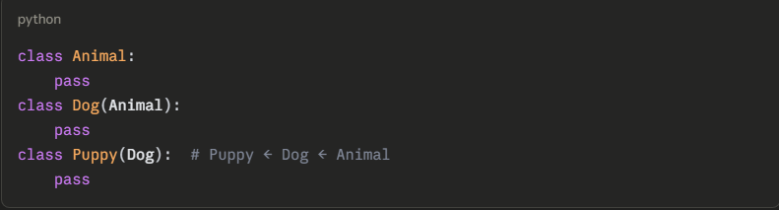

Heierarchical inheritance:
Multiple children inherit from a single parent class
Multilevel inheritance means a class is derived from another derived class, forming a chain (grandparent → parent → child).
Example:
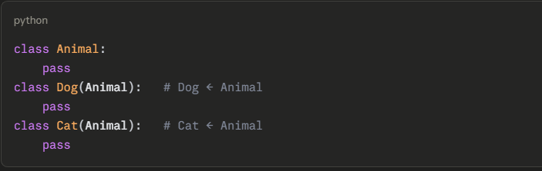

Method overriding in detail
Defination
- Method overriding means a child class creates a method with the same name as of parent class method and change its behavior
- Matlab : child class same name k sath aik method bnay jo k parent class main bhi h or us k behavior ko change kry
Basic idea
- It happened in inheritance
- Same method name in parent and child class
- If the object is created from child class the only child class method will be called not parent class method
How it works
- Parent class has a method
- Child classs inherit that parent class
- Child class also defined the method with the same name as of parent class
- Now child class method will be run with child class object

EXTRA point
Overriding inheritance main krty he isi liy hain k jo class child class inherit krhi hai us k method k behavior ko change kia jaa sky
Important rules
- Method name and parameters must be same
- Jo method overridden h ya jo method override kia h wo srf child object he use kry ge
- Parent method will still exist
About init overriding:
- If child has its own init method ,parent init method will not run
- If child class does not have its own init method the parent init method will run
- If child class has its own init method and we still want to run parent init method then we should use super() function
Key concept
Overriding never delte parent class method it only replace it for child class usage
Why we use it
- To change behavior of parent class method or to add functionality or modify functionality of that parent class method
- To reuse parent class method code
Overriding vs Overwriting
- Overriding is for methods in inheritance
- Overwriting is for chainging variable values
Conclusion
Child class can use the parent class features but can change them when needed
• Using super() properly in different cases
Definition:
When we have to call parent class method inside the child class
…………..
- Mostly we use it inside child classes
- We also use it in multiple inheritance
To avoid calling wrong wrong parent manualy cz in that we have multiple parent classes
- It is not alwys necassry it is only needed when we want parent behavior also,in child class along with the behavior of its own method
- Without super parent attributes will not exist,bcz parent init is not run and that is skipped

• Constructor chaining (__init__ flow in parent and child)
Constrauctor chaining means running parent and child class methods in a sequence during the creation of object
Object create ho ge to automatically __init__call hota h
To yani child class say object create hoe h to child class ka __init__ method call ho ga or us k baad parent class method call ho ga jo k super function use kr k hum child class main call krhy hain is sequence of calling child an dparent class method ko constructor chaining kehty hain
• isinstance() and issubclass() checks
Both are used in OOp to verify relationships
Isinstance is for objects
Cheks if an object is of a certain type isinstance(3, int) → True)

Issubclass is for classes themselves
Checks if the particular class is the subclass of a class or we can say if a class is inherit from another class
issubclass(Child, Parent)

• How attribute lookup works in inheritance (very important)
Attribute Lookup Order in Python Inheritance
- Attribute lookup means python un variables ya methods ko kesy find krta h jo aap ny abject k zariy acess kiy hoy hain
- Python follows MRO (Method Resolution Order) to search an attribute or method(the order python uses to srch attributes and methods)
- SIMPLE RULE
- Python frst look in the child class if the particular method we are accessing through an object is inside it or not
- Then for the parent class
- And then for the grandparent class
- Where evr it will find it it stops
Example
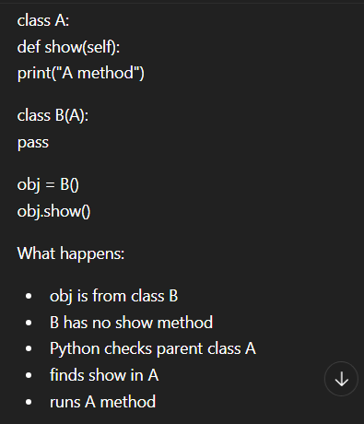

- Polymorphism
- Encapsulation
- Abstraction

